Supplementary material

Low cardiac output syndrome after adult cardiac surgery
A. Belletti, V.V. Lomivorotov, A. Zangrillo, M. Pieri

Details on mechanisms of actions of inotropes and vasopressors
Catecholamines (e.g., epinephrine, norepinephrine, dobutamine) exerts their effect through stimulation of adrenergic receptors [1–4]. The main cardiovascular adrenergic receptors subtypes include α-, β₁-, and β₂-adrenergic receptors: β₁-receptors stimulation produces and increase in ino- and chronotropism, while stimulation of β₂- and α-receptors produces vasodilation and vasoconstriction, respectively. The hemodynamic effect of the different catecholamines depends on the relative affinity for each receptor, and is summarized in Supplementary Table 1 (Ref. [3]).
Supplementary Table 1. Affinity of the different catecholamines for different adrenergic receptors. Adapted from Fellahi et al. [3].
Agonists | Receptors
 | α₁ | β₁ | β₂ | DA1
Inoconstrictors
• Norepinephrine | +++ | + | 0 | 0
• Epinephrine | +++ | +++ | ++ | 0
• Dopamine* | ++ | ++ | + | ++
Inodilators
• Dobutamine | + | +++ | ++ | 0
• Dopexamine | 0 | + | +++ | +
• Isoproterenol | 0 | +++ | +++ | 0
*The affinity of dopamine for different receptors is considered to be dose-dependent: dopaminergic effect for dose 2–5 μg/kg/min; β-agonist effect for dose 5–10 μg/kg/min; α-adrenergic effect for dose >10 μg/kg/min.

The mechanism of actions of catecholamines is presented in Supplementary Fig. 1 (Ref. [2]).
Supplementary Fig. 1. Mechanism of action of catecholamines. (A) β-adrenergic receptor signaling pathway. (B) α-adrenergic receptor signaling pathway. cAMP: cyclic adenosine monophosphate; DAG: diacylglycerol; PiP₂: phosphatidil-inositol-4,5-biphosphate; SR: sarcoplasmic reticulum. Adapted from Overgaard et al. [2].

Of note, catecholamines have well-known side effects on cardiovascular and other organ systems that include increased myocardial oxygen consumption, development of arrhythmias, induction of cardiomyocytes apoptosis [5], immunosuppressive and pro-thrombotic effects [6–8]. The main advantages of catecholamines are the short half-life that allows for rapid titration of the drugs to clinical effects, the longstanding experience in their clinical use, and the low costs. Indeed, catecholamines remain the most frequently administered vasoactives in critically ill patients, and the first-line drugs vasoactives drugs for patients with circulatory shock as recommended by several professional societies guidelines [9–15].
Phosphdiesterase-3 (PDE-3) inhibitors are the other major class of inotropes and generally the second most frequently administered in cardiac surgery patients. Differently from catecholamines, PDE-3 inhibitors do not have a specific receptor but act on the adrenergic system by blocking cyclic adenosine monophosphate degradation (cAMP), one of the key secondary messengers of the adrenergic receptor signaling pathway. Phosphdiesterase-3 inhibitors are characterized by an inodilatory effect (that may result in profound hypotension, especially in hypovolemic patients), a vasodilating effect on pulmonary circulation, a relatively long half-life, and possibility to produce cardiovascular effect even in case of beta-blockers on board or adrenergic receptor desensitization [8]. Similar to catecholamines, PDE-3 inhibitors increase myocardial oxygen consumption, can be pro-arrhythmogenic, and may induce myocyte apoptosis. Mechanism of action of PDE-3 is presented in Supplementary Fig. 2 (Ref. [2]). Notably, some laboratory studies suggest that PDE-3 inhibitors does not have direct inotropic activity and their hemodynamic effects are all due to modulation of pre- and afterload [16].
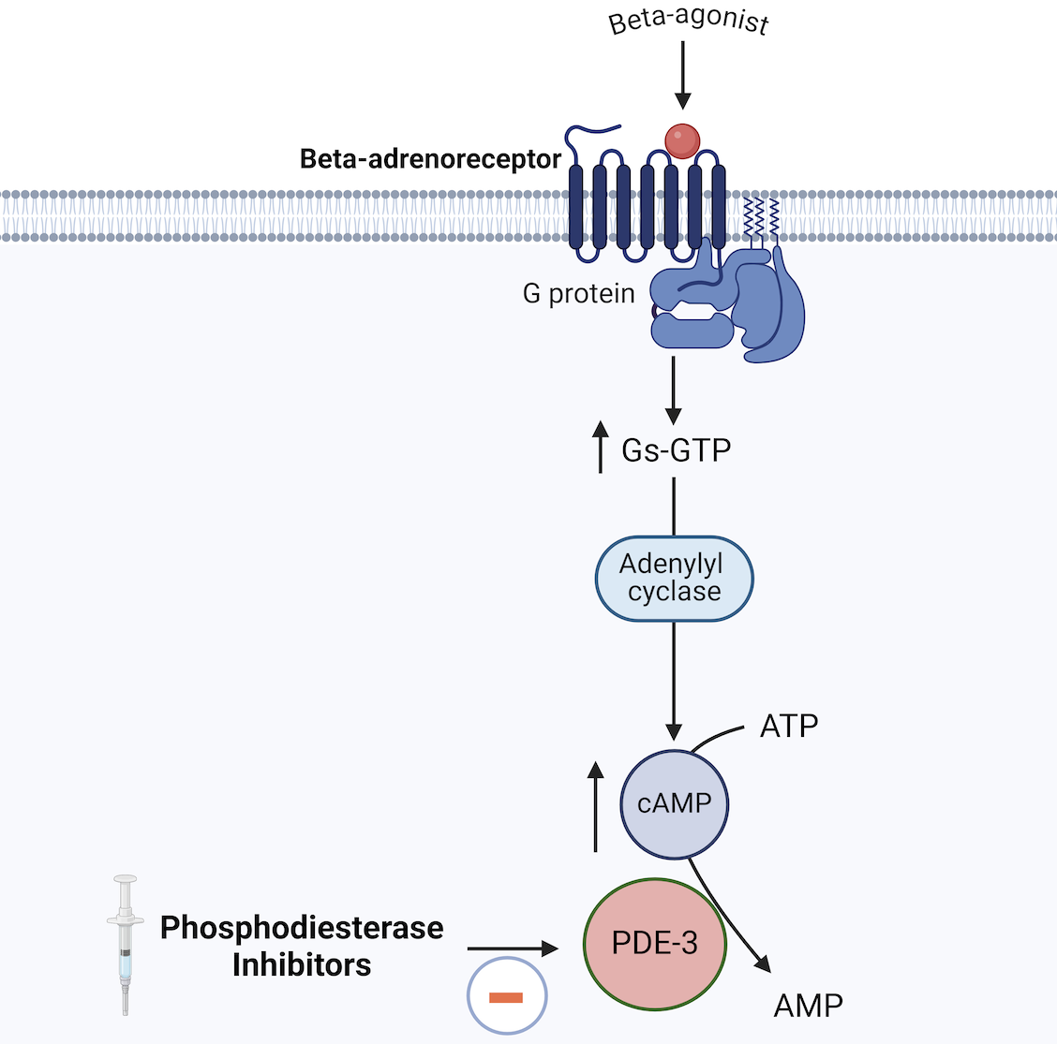
Supplementary Fig. 2. Mechanism of action of PDE-3 inhibitors. ATP: adenosine triphosphate; AMP: adenosine monophosphate; cAMP: cyclic adenosine monophosphate; Gs-GTP: Guanosine-stimulatory subunit- Guanosine triphosphate; PDE-3: Phosphodiestrerase-3. Adapted from Overgaard et al. [2].

Cardiac glycosides include digoxin and digitoxin. They exert their inotropic effect by inhibiting the Na⁺/K⁺ ATPase, leading to relative increase in Na⁺ concentration in cardiomyocytes cytosol. This, in turn, stimulates the Na⁺/Ca⁺⁺ exchanger, that will remove Na⁺ and introduce Ca⁺⁺ into the cell, ultimately increasing cytosolic Ca⁺⁺ concentration. Compared with catecholamines and PDE-3 inhibitors, cardiac glycosides have only a modest inotropic effect, have a narrow therapeutic index with a high risk of malignant arrhythmias, and have a very long half-life (more than 24 h). Therefore, their use is limited in the acute care setting. Of note, they are the only inotrope with a negative chronotropic effect.
Vasopressin and its derivatives (terlipressin, selepressin) are pure vasoconstrictors with little or no inotropic effect. Vasopressin stimulates vasopressinergic receptor-1 on vascular smooth muscle cells, that ultimately leads to increased cytosolic Ca⁺⁺ concentration and vasoconstriction [17, 18]. Being a pure vasoconstrictor, vasopressin is generally contraindicated in LCOS as it may dangerously increase LV afterload and further reduce CO [19, 20]. Its use is generally limited to cases of cardiogenic shock with profound, refractory hypotension, and always in combination with an inotropic agent.
Angiotensin II is an endogenous peptide with the effect of a pure vasoconstrictor [21]. Although it has been known for decades [21, 22], only recently has been reintroduced in clinical practice [21, 23, 24]. Angiotensin II effectively increases MAP and allows to decrease norepinephrine dose in patients with vasodilatory shock [24], and may improve survival in patients requiring renal-replacement therapy [25] or high plasma renin levels [26]. However, concerns on possible reduction in CO due to afterload increase apply also to angiotensin II. A pilot RCT in cardiac surgery patients suggested feasibility of angiotensin II use as primary vasopressor in cardiac surgery patients [27].
Levosimendan is an inodilatory agent that belongs to the class of calcium sensitizers. The mechanism of action of levosimendan is complex, and has been subject of several dedicated reviews and expert consensus conferences [28, 29].
The main mechanism of action of levosimendan is considered calcium sensibilization. Levosimendan binds to cardiac troponin C (cTnC) and and stabilizes the binding of Ca⁺⁺ and cTnC. This stabilization prolongs interaction between cTnC and cardiac troponin I (cTnI), ultimately improving strength of cardiomyocyte contraction but without increasing cytosolic Ca⁺⁺ levels. Therefore, levosimendan has the theoretical advantage of limited increase in myocardial oxygen consumption, as compared with other inotropes.
On vascular smooth muscle cells, opening ATP-sensitive K⁺ channels on cells membrane induce cellular hyperpolarization and therefore muscle relaxation and vasodilation. Furthermore, levosimendan has also some degree of PDE-3 activity, which further enhances its inodilatory effect.
Levosimendan has actives metabolites with a half-life of 70–80 hours, and a clinical effect that persists for days after a 24 h administration. The major side effects of levosimendan are hypotension and arrhythmias, similarly to PDE-3 inhibitors.
Interestingly, the classical view of levosimendan as a calcium sensitizer has been recently challenged by Ørstavik et al. [30], that showed that the hemodynamic effect of levosimendan are produced by its PDE-3 inhibitory action, with a negligible effect of calcium sensitizing properties.
Final overview of mechanisms of action of different inotropic agents is provided in Supplementary Fig. 3 (Ref. [3]).
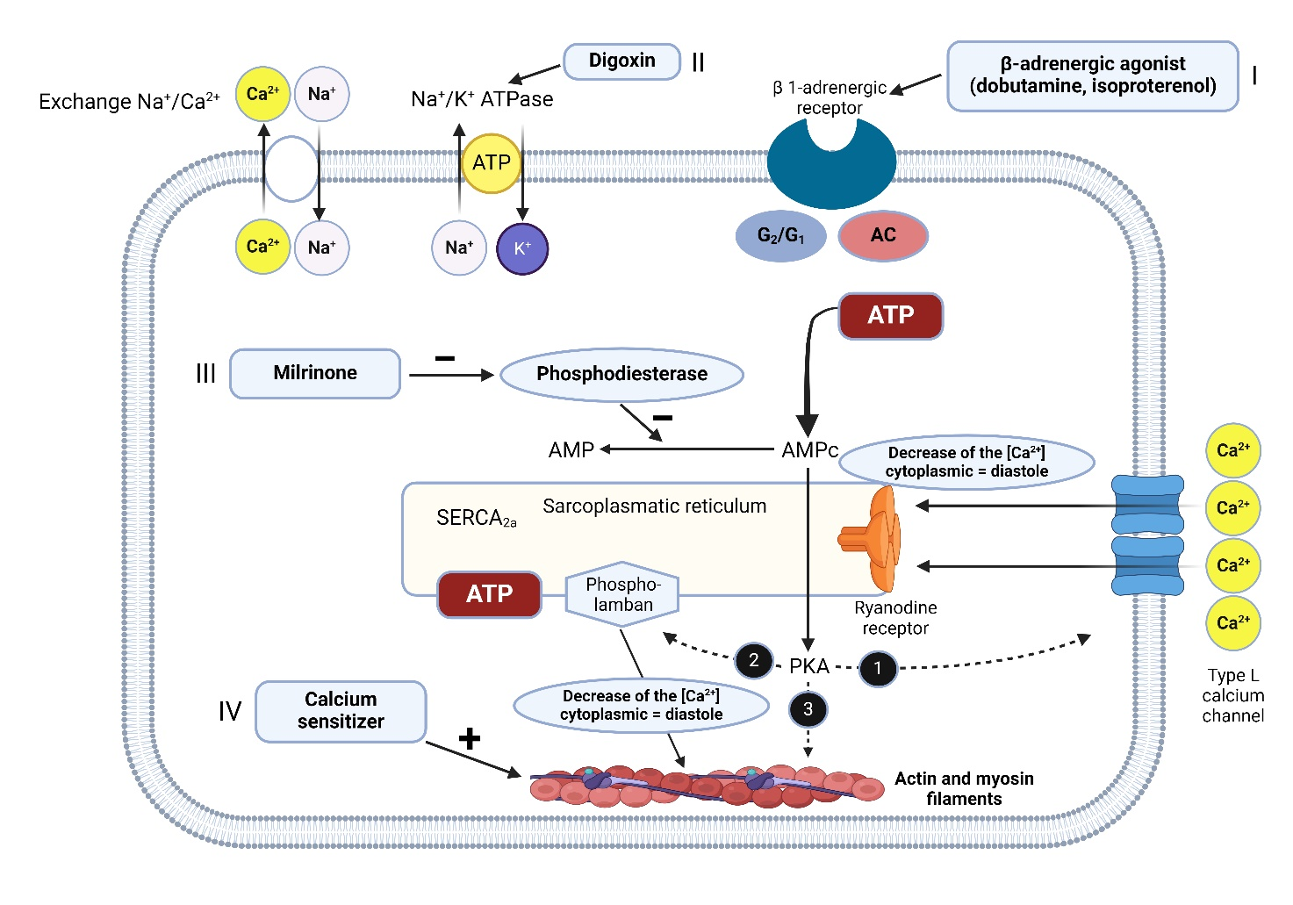
Supplementary Fig. 3. Summary of mechanisms of action on cardiac myocytes of different inotropes. AC: adenylate cyclase; ATP: adenosine triphosphate; cAMP: cyclic adenosine monophosphate; G1: stimulating G protein; G2: inhibitory G protein; PKA: protein kinase A; SERCA: sarcoplasmic reticulum calcium pump. Adapted from Fellahi et al. [3].

References
[1] Bangash MN, Kong ML, Pearse RM. Use of inotropes and vasopressor agents in critically ill patients. British Journal of Pharmacology. 2012; 165: 2015–2033.
[2] Overgaard CB, Dzavík V. Inotropes and vasopressors: review of physiology and clinical use in cardiovascular disease. Circulation. 2008; 118: 1047–1056.
[3] Fellahi JL, Fischer MO, Daccache G, Gerard JL, Hanouz JL. Positive inotropic agents in myocardial ischemia-reperfusion injury: a benefit/risk analysis. Anesthesiology. 2013; 118: 1460–1465.
[4] Jentzer JC, Coons JC, Link CB, Schmidhofer M. Pharmacotherapy update on the use of vasopressors and inotropes in the intensive care unit. Journal of Cardiovascular Pharmacology and Therapeutics. 2015; 20: 249–260.
[5] Singh K, Xiao L, Remondino A, Sawyer DB, Colucci WS. Adrenergic regulation of cardiac myocyte apoptosis. Journal of Cellular Physiology. 2001; 189: 257–265.
[6] Andreis DT, Singer M. Catecholamines for inflammatory shock: a Jekyll-and-Hyde conundrum. Intensive Care Medicine. 2016; 42: 1387–1397.
[7] Dünser MW, Hasibeder WR. Sympathetic overstimulation during critical illness: adverse effects of adrenergic stress. Journal of Intensive Care Medicine. 2009; 24: 293–316.
[8] Belletti A, Landoni G, Lomivorotov VV, Oriani A, Ajello S. Adrenergic downregulation in critical care: molecular mechanisms and therapeutic evidence. Journal of Cardiothoracic and Vascular Anesthesia. 2020; 34: 1023–1041.
[9] Evans L, Rhodes A, Alhazzani W, Antonelli M, Coopersmith CM, French C, et al. Surviving sepsis campaign: international guidelines for management of sepsis and septic shock 2021. Critical Care Medicine. 2021; 49: e1063–e1143.
[10] Mebazaa A, Tolppanen H, Mueller C, Lassus J, DiSomma S, Baksyte G, et al. Acute heart failure and cardiogenic shock: a multidisciplinary practical guidance. Intensive Care Medicine. 2016; 42: 147–163.
[11] Van Diepen S, Katz JN, Albert NM, Henry TD, Jacobs AK, Kapur NK, et al. Contemporary management of cardiogenic shock: a scientific statement from the American Heart Association. Circulation. 2017; 136: e232–e268.
[12] Mebazaa A, Combes A, van Diepen S, Hollinger A, Katz JN, Landoni G, et al. Management of cardiogenic shock complicating myocardial infarction. Intensive Care Medicine. 2018; 44: 760–773.
[13] Chioncel O, Parissis J, Mebazaa A, Thiele H, Desch S, Bauersachs J, et al. Epidemiology, pathophysiology and contemporary management of cardiogenic shock—a position statement from the Heart Failure Association of the European Society of Cardiology. European Journal of Heart Failure. 2020; 22: 1315–1341.
[14] Møller MH, Claudius C, Junttila E, Haney M, Oscarsson-Tibblin A, Haavind A, et al. Scandinavian SSAI clinical practice guideline on choice of first-line vasopressor for patients with acute circulatory failure. Acta Anaesthesiologica Scandinavica. 2016; 60: 1347–1366.
[15] Møller MH, Granholm A, Junttila E, Haney M, Oscarsson-Tibblin A, Haavind A, et al. Scandinavian SSAI clinical practice guideline on choice of inotropic agent for patients with acute circulatory failure. Acta Anaesthesiologica Scandinavica. 2018; 62: 420–450.
[16] DeWitt ES, Black KJ, Thiagarajan RR, DiNardo JA, Colan SD, McGowan FX, et al. Effects of commonly used inotropes on myocardial function and oxygen consumption under constant ventricular loading conditions. Journal of Applied Physiology. 2016; 121: 7–14.
[17] Russell JA. Bench-to-bedside review: vasopressin in the management of septic shock. Critical Care. 2011; 15: 226.
[18] Nagendran M, Russell JA, Walley KR, Brett SJ, Perkins GD, Hajjar L, et al. Vasopressin in septic shock: an individual patient data meta-analysis of randomised controlled trials. Intensive Care Medicine. 2019; 45: 844–855.
[19] Thiele RH, Nemergut EC, Lynch C. The physiologic implications of isolated alpha(1) adrenergic stimulation. Anesthesia & Analgesia. 2011; 113: 284–296.
[20] Thiele RH, Nemergut EC, Lynch C. The clinical implications of isolated alpha(1) adrenergic stimulation. Anesthesia & Analgesia. 2011; 113: 297–304.
[21] Bellomo R, Zarbock A, Landoni G. Angiotensin II. Intensive Care Medicine. 2024; 50: 279–282.
[22] Bennett SR, McKeown J, Drew P, Griffin S. Angiotensin in cardiac surgery: efficacy in patients on angiotensin converting enzyme inhibitors. European Journal of Heart Failure. 2001; 3: 587–592.
[23] Landoni G, Cortegiani A, Bignami E, De Pascale G, Donadello K, Donati A, et al. The use of angiotensin II for the management of distributive shock: expert consensus statements. Journal of Anesthesia, Analgesia and Critical Care. 2024; 4: 56.
[24] Khanna A, English SW, Wang XS, Ham K, Tumlin J, Szerlip H, et al. Angiotensin II for the treatment of vasodilatory shock. The New England Journal of Medicine. 2017; 377: 419–430.
[25] Tumlin JA, Murugan R, Deane AM, Ostermann M, Busse LW, Ham KR, et al. Outcomes in patients with vasodilatory shock and renal replacement therapy treated with intravenous angiotensin II. Critical Care Medicine. 2018; 46: 949–957.
[26] Bellomo R, Forni LG, Busse LW, McCurdy MT, Ham KR, Boldt DW, et al. Renin and survival in patients given angiotensin II for catecholamine-resistant vasodilatory shock. A clinical trial. American Journal of Respiratory and Critical Care Medicine. 2020; 202: 1253–1261.
[27] Coulson TG, Miles LF, Serpa Neto A, Pilcher D, Weinberg L, Landoni G, et al. A double-blind randomised feasibility trial of angiotensin-2 in cardiac surgery. Anaesthesia. 2022; 77: 999–1009.
[28] Papp Z, Édes I, Fruhwald S, De Hert SG, Salmenperä M, Leppikangas H, et al. Levosimendan: molecular mechanisms and clinical implications: consensus of experts on the mechanisms of action of levosimendan. International Journal of Cardiology. 2012; 159: 82–87.
[29] Nieminen MS, Fruhwald S, Heunks LMA, Suominen PK, Gordon AC, Kivikko M, et al. Levosimendan: current data, clinical use and future development. Heart, Lung and Vessels. 2013; 5: 227–245.
[30] Ørstavik O, Ata SH, Riise J, Dahl CP, Andersen GØ, Levy FO, et al. Inhibition of phosphodiesterase-3 by levosimendan is sufficient to account for its inotropic effect in failing human heart. British Journal of Pharmacology. 2014; 171: 5169–5181.

